**Project 1**

**Elementary Reading**

**Expert System**

**Haziq Saeed**

**CSC 180**

**Fall 2017**

**Introduction and Background**

**Overview**

Students are assessed every year in the beginning of Fall semester to determine their reading levels for their current grade level. My interviewee is a Paraeducator for reading at Davis Korematsu Elementary, who assist teachers and other school aides with many tasks, but she mainly help students to read at or above their grade levels. To do this, she assessed students on their reading with variety of assessments such as Rigby or Benchmark. The assessment allows reading paras to understand where each student is at in their reading journey. Later, they work individually or in groups with students to help them improve or excel above their reading levels.

**Motivation/Problem Solving**

This is definitely a process that requires many steps to determine a student’s reading level, which can be a trying process when working with young students. Sometimes youngers grades feel pressure and nervous when they hear the words “assessment” or “test” or if they are not familiar with the person assessing them, and their nervousness can cause them to do poorly. Therefore, it’s important for the instructor to familiarize him or herself with students before assessing them. Overall motivation for this project is to determine student’s reading level by assessing them on reading and reading comprehension.

**Knowledge Engineering**

**Expert:**

My expert currently works at Korematsu Elementary School in Davis, California. She’s a paraeducator for reading. Currently, because it is the beginning of the school year, she is assessing students in first and second grade levels to determine their reading levels, reading skills, and reading comprehension.

**Summary (Job Title)**

Provides a variety of instructional, clerical, and group behavior assistance to individual or small groups of students in support of special instructional programs. May provide other support services such as translation. Assists certificated staff in the preparation and use of materials to enhance the student learning experience.

**Interview:**

I simply had created a list of questions that I wanted to ask the expert ahead of the interview. Some of the questions were just to ask for the overall purpose and general ideas that usually goes behind and creating these assessment for students. For example, “How do you exactly determines a student reading level just based on a assessment?”. Then I just recorded her answers and after understanding the general concept from the expert.

To get better understanding of the process, I was given series of assessment questions which would be asked during the assessment. I mainly would try to expand on this idea and try extract as much information as I could from my expert. Also, try to narrow down her ideas, as to how to determine a student’s reading levels or how do you determine the book based on their reading levels?

**Knowledge of Engineering(Constrain Questions)**

What kind books are suggested to students usually?

* I have not suggested any books at the moment because I’m still in the process of assessing students in second grade. Once all the assessments are done and graded, the reading staff will put students who need the extra help with their reading in 1st and 2nd grade. Then, I alongside the other reading staff will work with a group of students to have them read at their grade level or above.

What kind of genre the students are required to read at their current grade level?

-This depends on the class. Some teachers ask for students to read at home and some assign class books. Overall, students have a lot of freedom to choose from the different genres like (fairytales, fiction, non fiction, science, animals, space, etc). As for the assessments, the stories or the books they read are either fiction or nonfiction.

How does a district determines as to what level a students need to be placed in?

-Each school does it differently, but at Korematsu there’s a reading scale which shows where each student should be reading during or the end of the their grade level. Assessments are done to determine where the students are on the scale and if they are above or below their grade reading levels.

How does the reading progresses over each grade level?

-The reading progresses over the course of levels. As the student’s move up the level, they are exposed to advanced vocabulary, less pattern reading, and harder comprehension questions.

Are the students allowed to ask for different reading words?

-If a student has difficulty recognizing words in a story while testing or reading, I ask them to recall on their reading strategies which they are introduced to in first grade. For example: Stretchy the Snake means stretch the word out with sounds.

How you determine score for each level?

-Currently, I’m using Rigby to determine the reading levels of 1st and 2nd grade, in which each book is a level.

They need 95 % or higher to pass a level

**Overview**

The user is prompted with series of questions before , even taking the exam. Series of questions that are ask in the following way. The first first question is to determine whether the student is part of Davis school district or not. Because the assessment is only meant for the student students that are part of Davis District. If the student has given valid answer (being yes) then the student is asked to enter his or her name. This is follow by entering the instructor name, that will be conducting the assessment. Because the instructor is one of the constrain for this assessment, because the reading part of exam has to be monitor by a instructor, to determine the students reading errors(reading errors being one of the inputs). Next instruction takes the student Grade Level, the student must select grade one to grade three. This instruction provides the student with three choices to select from, but it doesn’t follows the convention of software testing.

Some of the next rules are to get the user understanding of the reading level. The user promoted with simple text promote that tell them basic information regarding assessment. Some of the keys things that the instructor must be present for this part of assessment and they must get 90% or higher. This one of the changes, that I made regarding how much student needs to pass, because according to my expert student must get 95 % or higher to pass a reading level. Student must read the following text to the instructor, and the instructor determines the amount time a student has misread a word. That is taken as input in terms of errors student has made. Input is used to determine the student percentage on the reading part of the assessment. If the student were not able to passed the reading part of the assessment , one of the rule is fire which assert fail state for the first reading. After that it will promote them to take comprehension part of the assessment, this rule get fire only if the state is passed or failed.

The comprehensive part of the assessment is used to determine student understanding of the reading. They are promoted with series of questions and are provided choices for each of the questions. They must get all the answer right in order to pass this part. Expert system can recognize all the wrong answer that the student can enter given only three choices to pick from.

The following figures shows, how the facts are initialized during run time of the program.

|  |
| --- |
| (deffacts wrongStates  (state 1 1)(state 2 1)( state 3 1)  (state 1 2)(state 2 2) (state 3 2)  (state 2 3)(state 3 3)) |

**Expert System Design**

To determine the input for each of the fuzzification part of the fuzzy logic. I had to decide on two main inputs. One of the inputs is asking the student to enter the amount of books they have read over the summer. To make the input fuzzy , graph is broken down slightly proficient, average, and proficient. The maximum books the student should enter is only ten and the reason is to be precise. The second input is asking the student to provide the difficult level of the books they have read in overall. Scale for the difficult is from one to ten. One to four being slightly difficult and 3.5 to 7.5 being average difficulty, and last one from 7 to 10 being very difficult.

Graph 1.1

|  |  |
| --- | --- |
|  | **Amount Books Read**  **((Sp (0 1) (3 0))**  **(Avg (2 0) (4 1) (6 0))**  **(Pro (5 0) (8 1)))**  Sp = Slightly Proficient  Avg = Average  Pro = Proficient |

Graph 1.2

|  |  |
| --- | --- |
|  | **Difficult of the reading**  **((Sp (0 1) (100 0))**  **(Avg (75 0) (150 1) (225 0))**  **(Pro (200 0) (300 1)))**  Sp = Slightly Proficient  Avg = Average  Pro = Proficient |

The output is fuzzy on scale of 0 to 100. The graph is broken down from not proficient to proficient. Mid point of the graph is mainly includes students that fall under being slightly proficient to being average at reading.

Graph 1.3

|  |  |
| --- | --- |
|  | **((Np (0 1) (20 0))**  **(Sp (15 0) (30 1) (45 0))**  **(Avg (40 0) (60 1) (80 0))**  **(Pro (75 0) (100 1)))**  Np = Not Proficient  Sp = Slightly Proficient  Avg = Average  AA= Above Average  Pro = Proficient |

**Fuzzy Associative Matrix(FAM)**

Fuzzy Associative Matrix took long time, because I had keep making changes to get as much accurate value as I could have. On my first attempt the value were not accurate at all, it was definitely output the wrong result. After a lot of different testing it start to generate a accuarte output. FAM would generate a lot of student that fall under being average and only few percentage of student being proficient entirely.

Chart 1.1

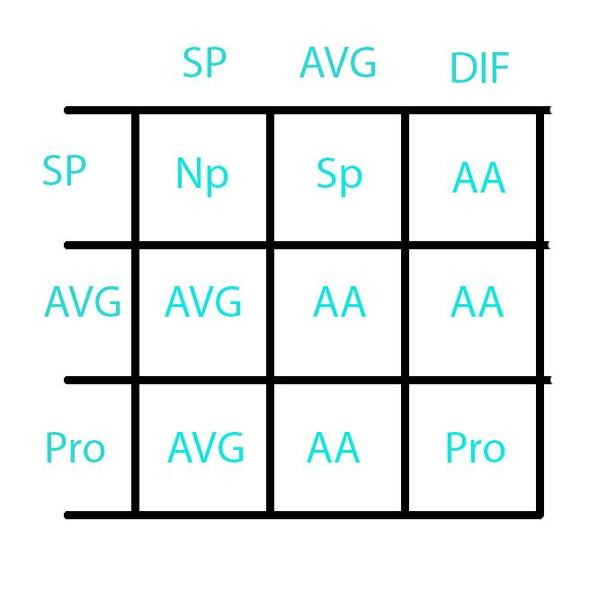

**Conclusion**

Approach of getting user inputs work well, because the expert system is heavily depended on user input. It provides the exact answers for each of the reading assessment level, because either the student understand the material or they don’t. If the student doesn’t understand material, for example answering the wrong answer on the comprehensive part of the assessment. They wouldn’t pass that certain level at all. To keep the application simple there are only three levels that student must pass. According to expert they usually have up to 30 different levels, each progressively get difficult with each level.

Fuzzy logic does indeed provide the answers, but the only flaw I see is that, they can lie on the amount books they have read. Their really no way for me tell, as to if the student is telling the truth, through using fuzzy logic part. The one way, I could tell is through the reading assessment and comprehensive part of the assessment. If they pass all the three level it shows that to the instructor they definitely are telling the truth. That why after taking the reading and comprehensive part of the assessment, they are asked to enter the fuzzy logic inputs.

Know bug for the system is that if the user enters 1 or 2 for the books read and 1 or 2 for difficulty, it doesn’t work. I definitely learned a lot by working by myself, even though it was challenging getting the fuzzy logic part working. I believe, it work efficiently to point, where it can judge student proficiently level.

**APPENDIX A (installation guide)**

Step 1 . Click on the link below to download Clips

<https://sourceforge.net/projects/clipsrules/files/latest/download?source=files>

Step 2. Open the folder and click on CLIPSIDE.exe to start Clips

Step 3. Click on File -> Load Construct -> ExpertSystem.CLP

Step 4. To run the program you must enter the following commands with parathences.

(reset)

(run)

Step 5. If any changes made to the Expert System.CLP file must be save(Ctrl +S)

Step 6. To run the program again, you need to type the following command with parentheses.

* (clear) // This clear the facts
* Follow step 3 again

**APPENDIX B (user’s guide)**

The following page will provide the user better understanding of inputting data and understanding the output.

|  |
| --- |
| Davis Joint Unified School District  Student Reading Assessment  Is your school part of Davis Joint Unified School District ? Yes/ No |
| This question is only used to make sure, if your district is part of Davis. Input: Answer the question in terms of Yes or No.  >> Yes  or  >> No |

|  |
| --- |
| "Enter the Student First Name? "  “Enter the Instructor Name? |
| Only need the first name to keep the application simple. User just need to input name.  >> Haziq  For the Instructor.  >> Mike |

|  |
| --- |
| "How many errors did the student made on the following reading?" |
| Instructor just need enter the exact amount errors student has made.  >> 10  If it’s greater than 5 the student will be promoted by the following message.  >>"Student:Failed  >>"Student must get 90% or higher to pass the reading exercise." |

|  |
| --- |
| >>" What did the boy do ? "crlf  "(1) read (2) jumped (3) walked" |
| Student must select only the following number from the keypad 1 or 2 or 3. Any other number wouldn’t be taken by the system. |

The following output only happens on two condition. Student pass or fails the reading assessment. Or the student doesn’t answer right answer for the comprehensive part. This output provides the student with a suggestion that they must follow. If the student pass all the level he or she will not see this message. Because according to the expert they just move on to the next level.

|  |
| --- |
| --------------Report--------------------  Reading Level 1 : Failed  The student needs a lot of practice on his reading skills.  Book Suggested: Frog and Toad Are Friends  ---------------------------------- |
| --------------Report--------------------  Reading Level 2 : Failed  The student is slight proficient at reading. Student still needs a lot of practice on his reading skills.  Book Suggested: The Best Seat in Second Grade  ---------------------------------- |
| --------------Report--------------------  Reading Level 3 : Failed  The student is Above Average proficient at reading. Student still needs a lot of practice on his reading skills.  Book Suggested: Superfuge  "----------------------------------" |

|  |
| --- |
| The end of the result of the application is based on the scale. Check the fuzzy output diagram.  >>Enter amount of books you have read over the summer.  >> Enter the difficult of the book.(Scale 1 to 10). |
| Fuzzy part output the value, to get a proper idea what the value means the instructor must look at graph 1.3. This will provide a better understanding of the value, that is being output by the fuzzy generator. |

**Exercise 1** (find path from fairfield to davis)

I was finally able to get this exercise working, it does indeed work for the input from fairfield to davis. It works for other condition like from Chico to Sacramento, but it doesn’t know when it stop firing each rules. I mainly focused on the main project, otherwise I would have fixed this issues.

**References**

Saeed, Sharmeen,(2017,09,12).Interview type[personal interview] Expert System